Eco
Handheld Thermal Camera

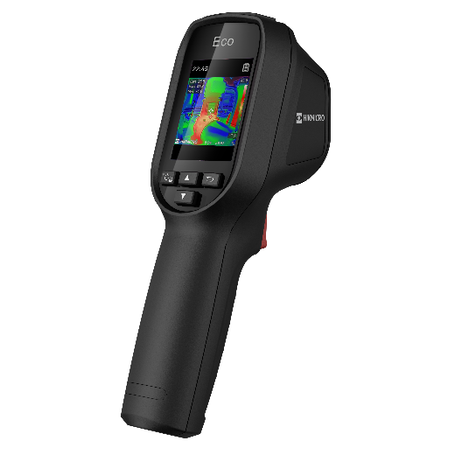

The handheld thermal camera is based on the thermal technology, specially designed for the needs of temperature measuring applications. People can quickly troubleshoot faults on-site.

Key Feature
- Thermal resolution: 96 × 96 (9,216 pixels)
- 112:1 Distance to spot ratio (D:S)
- SuperIR: 240 × 240 (57,600 pixels)
- NETD: < 50 mK (@ 25°C, F# = 1.0)
- Measurement presets: center spot, hot spot, cold spot, off
- 25 Hz image frequency
- Laser pointer
- Built-in 4 GB flash memory: 30,000 pictures
- Up to 8 hours continuous running

- Specification
Infrared Image
IR Resolution | 96 × 96 (9,216 pixels)
SuperIR | 240 × 240 (57,600 pixels)
Distance to Spot Ratio (D:S) | 112:1
NETD | < 50 mK (@ 25°C, F# = 1.0)
Image Frequency | 25 Hz
Detector Pitch | 12 μm
Spectral Range | 7.5 to 14 μm
Focal Length | 1.35 mm
F-number | F1.0
Field of View (FOV) | 50° × 50°
Spatial Resolution (IFOV) | 8.89 mrad
Min. Focus Distance | 0.1 m (0.33 ft)
Focus Mode | Focus Free
Image Display
Display | 240 × 320 Resolution, 2.4”LCD Screen
Image Modes | Thermal
Color Palettes | White Hot, Black Hot, Rainbow, Ironbow, Red Hot
Color Alarm | Above alarm
Measurement and Analysis
Object Temperature Range | -20°C to 550°C (-4°F to 1022°F)
Accuracy | Max (± 2°C/3.6°F, ± 2%), for ambient temperature 15°C to 35°C (59°F to 95°F) and object temperature above 0°C (32°F)
Measurement Tools | Center Spot, Hot Spot, Cold Spot
Level and Span Mode | Auto
Data Storage and Communication
Storage Media | Built-in 4 GB flash memory
Image Storage Capacity | Approx. 30,000 Images
General
USB Interface | USB Type-C
Laser | Yes, Class II
Battery Type | Rechargeable Li-ion battery
Battery Charging Time | Approx. 3 hours fully charged(Adapter Output: 5 V 2 A)
Battery Operating Time | Approx. 8 hours
Protection Level | IP54
Drop Test Height | 2 m (6.56 ft)
Working Temperature Range | -10°C to 50°C (14°F to 122°F)
Storage Temperature Range | -40°C to 70°C (-40°F to 158°F)
Relative Humidity | < 95% non-condensing
Weight | Approx. 335 g (0.74 lb)
Dimension | 196 × 117 × 59 mm (7.7” × 4.6” × 2.3”)
Tripod Mounting | UNC ¼”-20

- Available Model
Eco

- Dimension
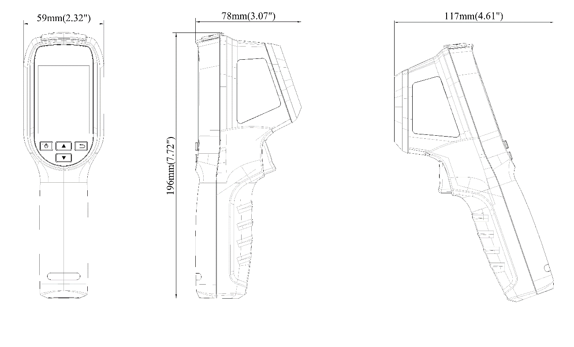
Unit: mm (Inch)

- Accessory
- Optional

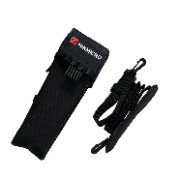
HM-B01-POUCH
COMPLIANCE NOTICE: The thermal series products might be subject to export controls in various countries or regions, including without limitation, the United States, European Union, United Kingdom and/or other member countries of the Wassenaar Arrangement. Please consult your professional legal or compliance expert or local government authorities for any necessary export license requirements if you intend to transfer, export, re-export the thermal series products between different countries.

